Field Test 2 – Algorithm Calibration

Testing occurred outside of a lab building at Sandia National Laboratories.

The sensors were all at 90 degrees from the “x-axis” and spaced from the center as follows: 3’, 0.5’, 0.5’, 3’. The sensors were outside during the tests (not pictured).

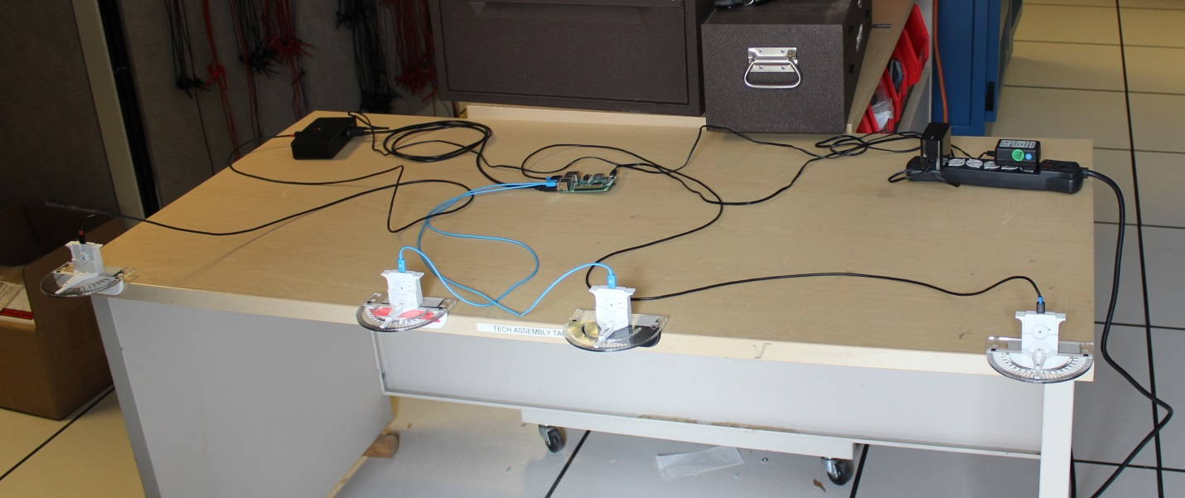

Testing was performed from 9:50 to 11:15 pm and the temperature ranged from approximately 70 to 83 degrees Fahrenheit.

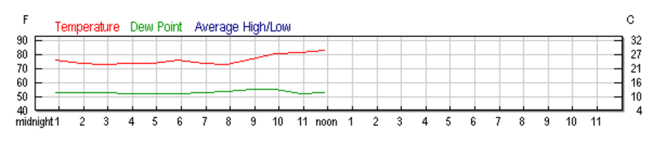

The test subject was a person walking back and forth in front of the sensors. Data was gathered six times (9:50, 10:00, 10:10, 10:20, 10:30, 11:15) and the algorithm was adjusted to remove false positives and more accurately calculate statistics.

Algorithm changes:

All tests

Statistic threshold of detection: 6 sigma

Changed pixels to trigger detection: 30

Pixel window: 6x6 center pixels

9:50

Pixels outside of + - 30 from mean not added

10:00

Fixed algorithm (logic was inverted)

Fixed standard deviation calculation (not divided by MAGIC)

10:10, 10:20, 10:30, 11:15, 11:45 – Data gathered with current algorithm

12:30 – head in to avoid rain

The Problem Targeted

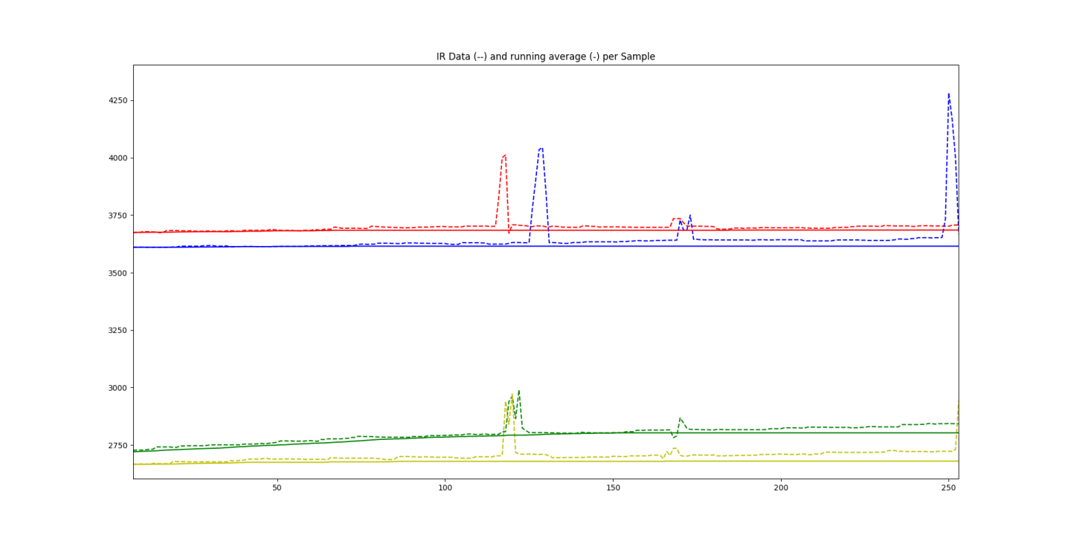

This data was gathered outside the day before this test. The IR data can be seen pulling away from the running average the algorithm should be tracking. This is caused by sudden shifts in a few fractions of a degree in temperature after a long period of stability. The standard deviation has been driven very low by at least a window’s worth of closely clustered samples so that the small shift in temperature (15 to 20 sensor value) causes the pixel to alert and reject the values from the running average window.

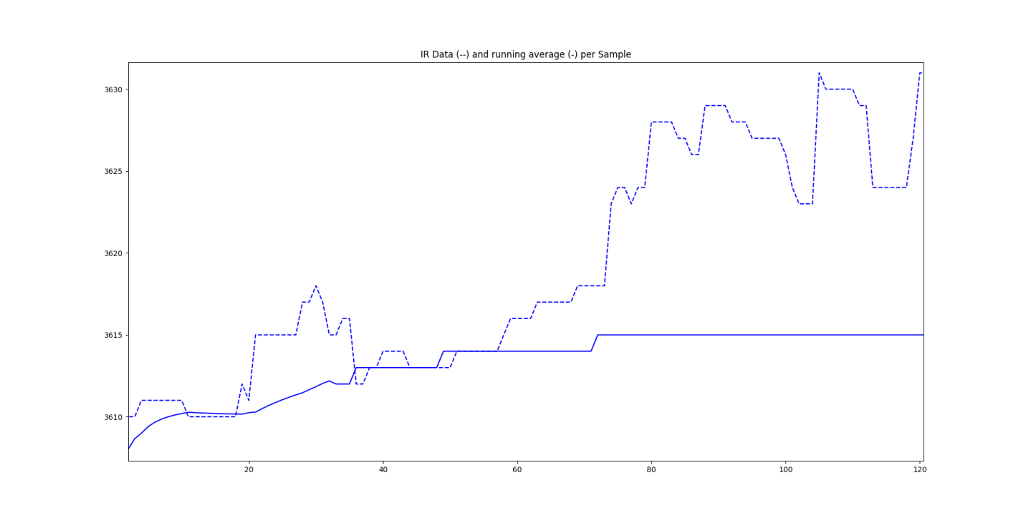This image illustrates the problem: from sample 0 to sixty the average is reasonably tracked and the variance of the data is reasonably stable. When the environment being monitored heats up slightly around sample 70 the standard deviation is low enough that the temperature is now running away from the mean, and every sample moving forward is rejected and causes an alert.

To fix this problem an additional test will be added to the algorithm. The alert detection will work the same: if the pixel is outside of six standard deviations it will count toward the alert total, but a new algorithm will be introduced to determine if the sample should be added to the running window or not. Based on previously gathered data shifts in temperature between samples should not exceed 20 to 30 sensor value. Thus a simple window of plus or minus thirty around the current mean should be sufficient to indicate whether or not the incoming value should be added to the window or not. This is the implemented algorithm.

9:50

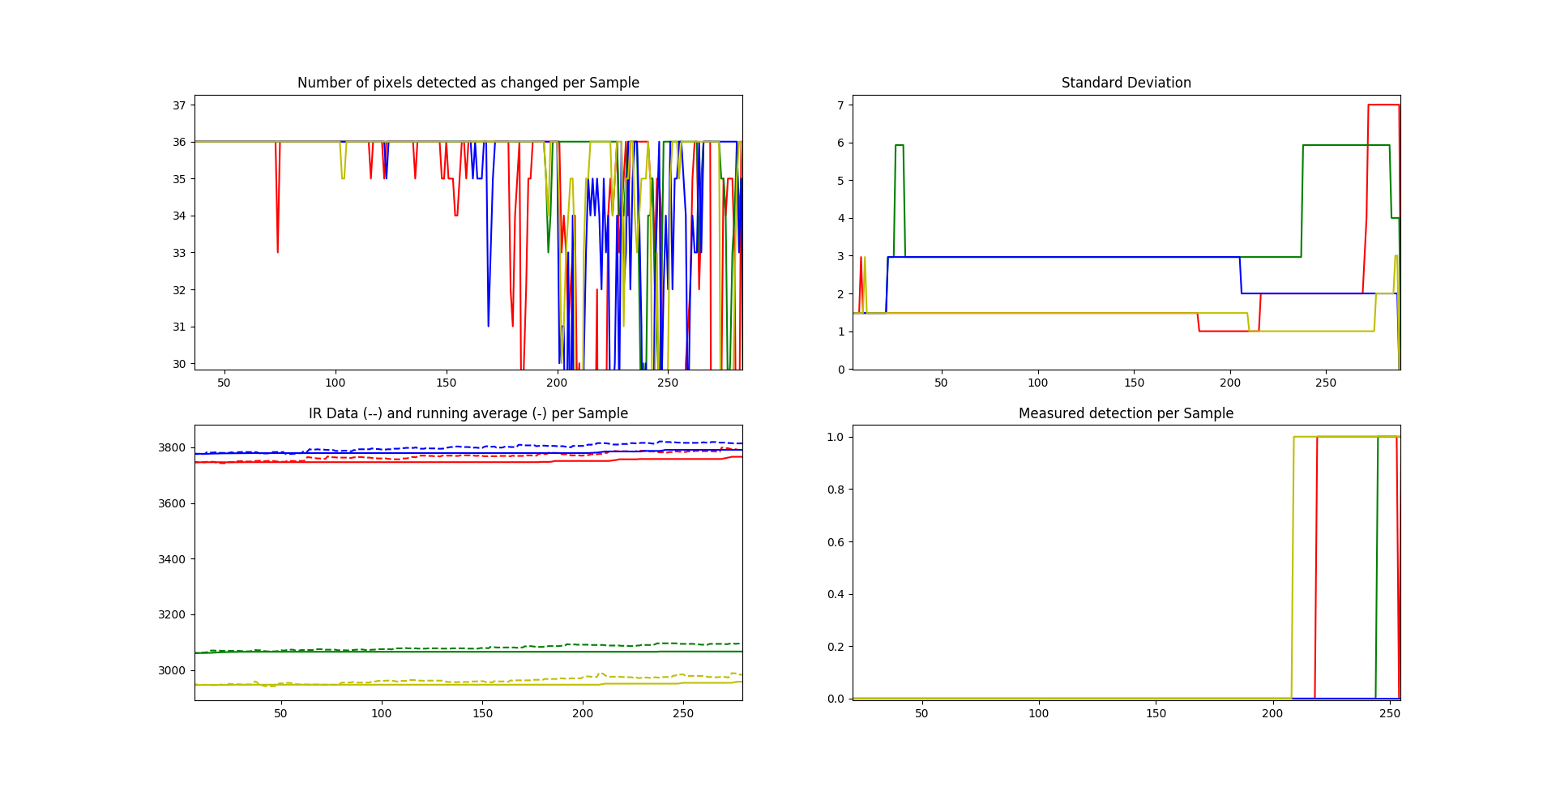

The data here is poor due to inverting the logic of the added algorithm. The mean still is left behind as the environment heats up. Data was gathered for approximately 30 seconds.

10:00 and 10:10 – Steady State tests

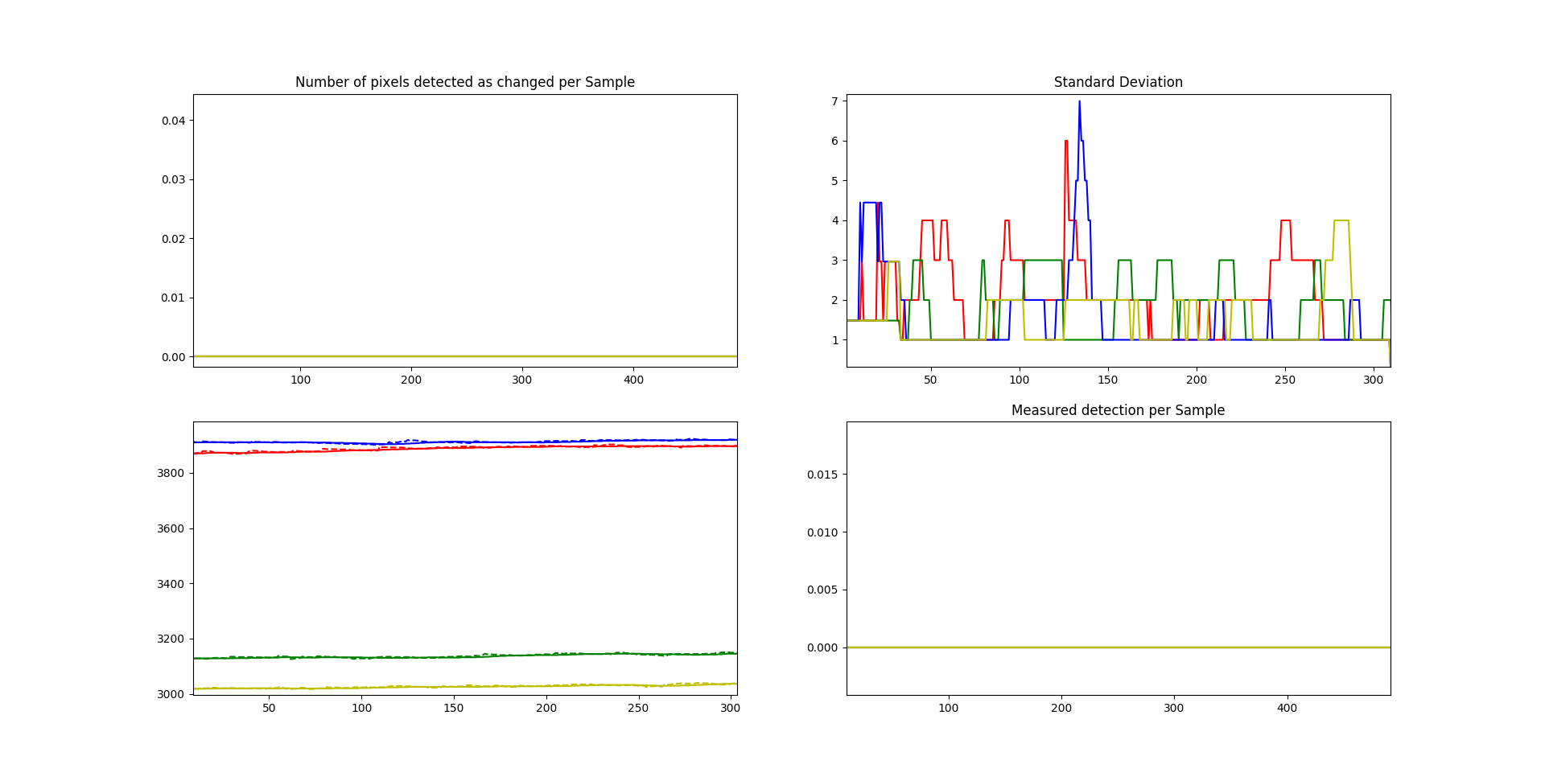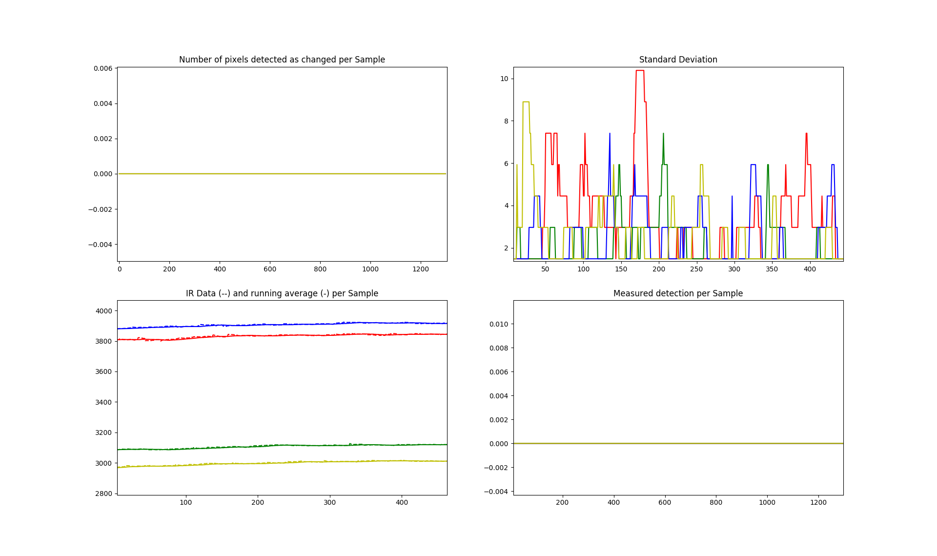

No detections occur during the stead state tests which went on for 30 and 50 seconds respectively. This data shows the upward trend of the temperature not causing false alerts while the mean tracks closely with the IR data.

10:20 – Intrusion detection

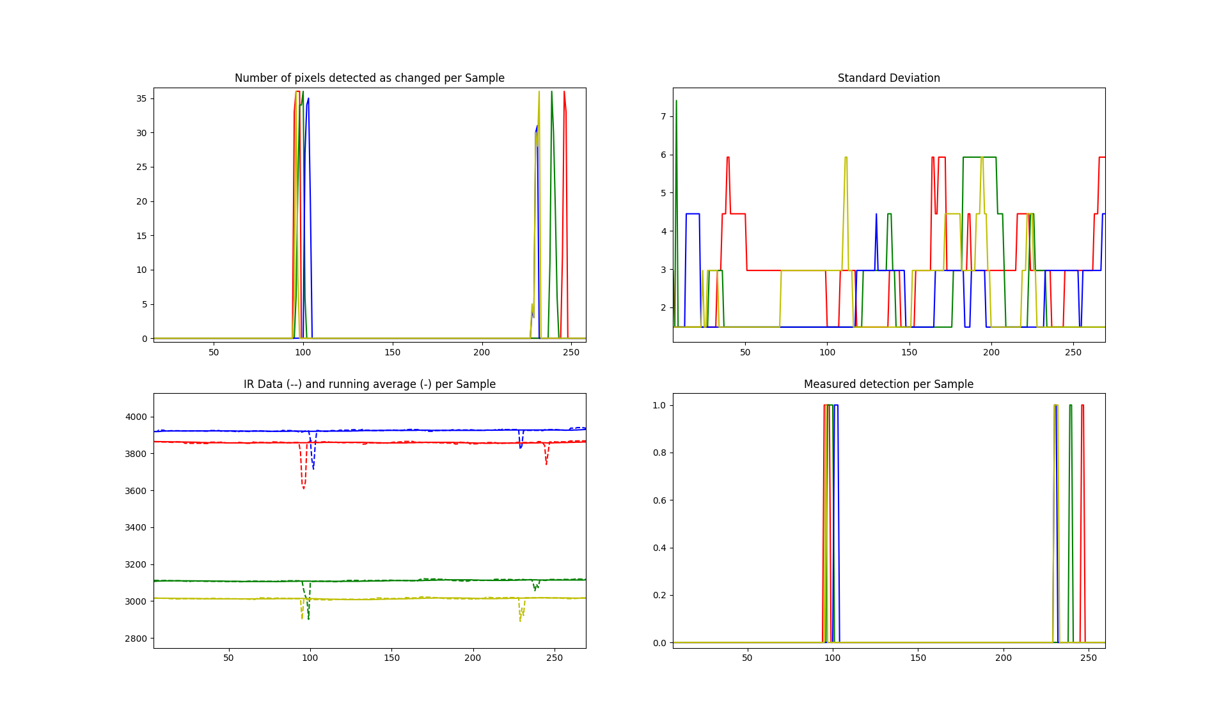

The test subject walked back and forth once in this 30 second test. The short nature of the test did not allow the temperature of the surroundings to shift much, however the algorithm did a great job of picking out the intrusions.

10:30

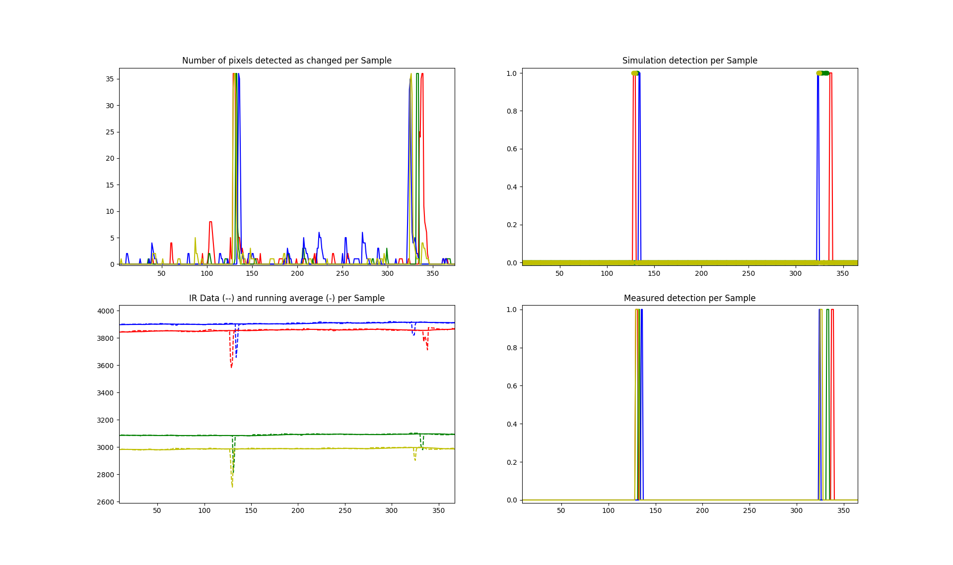

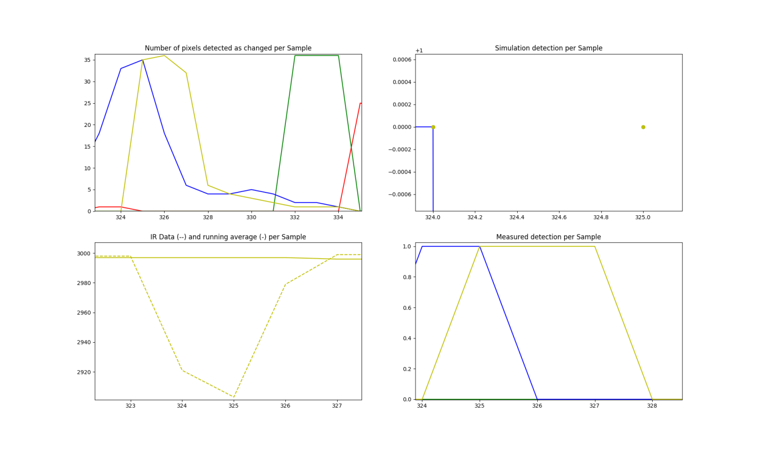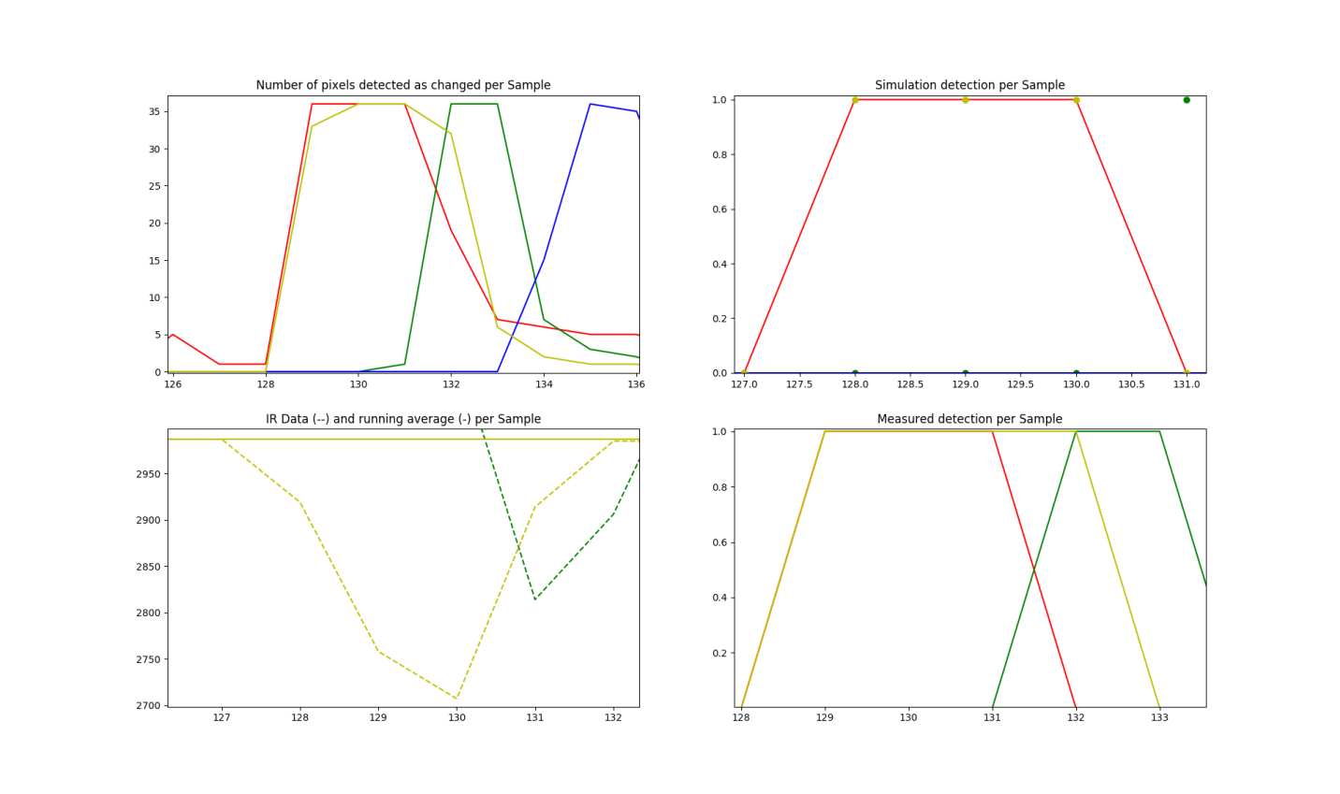

11:15

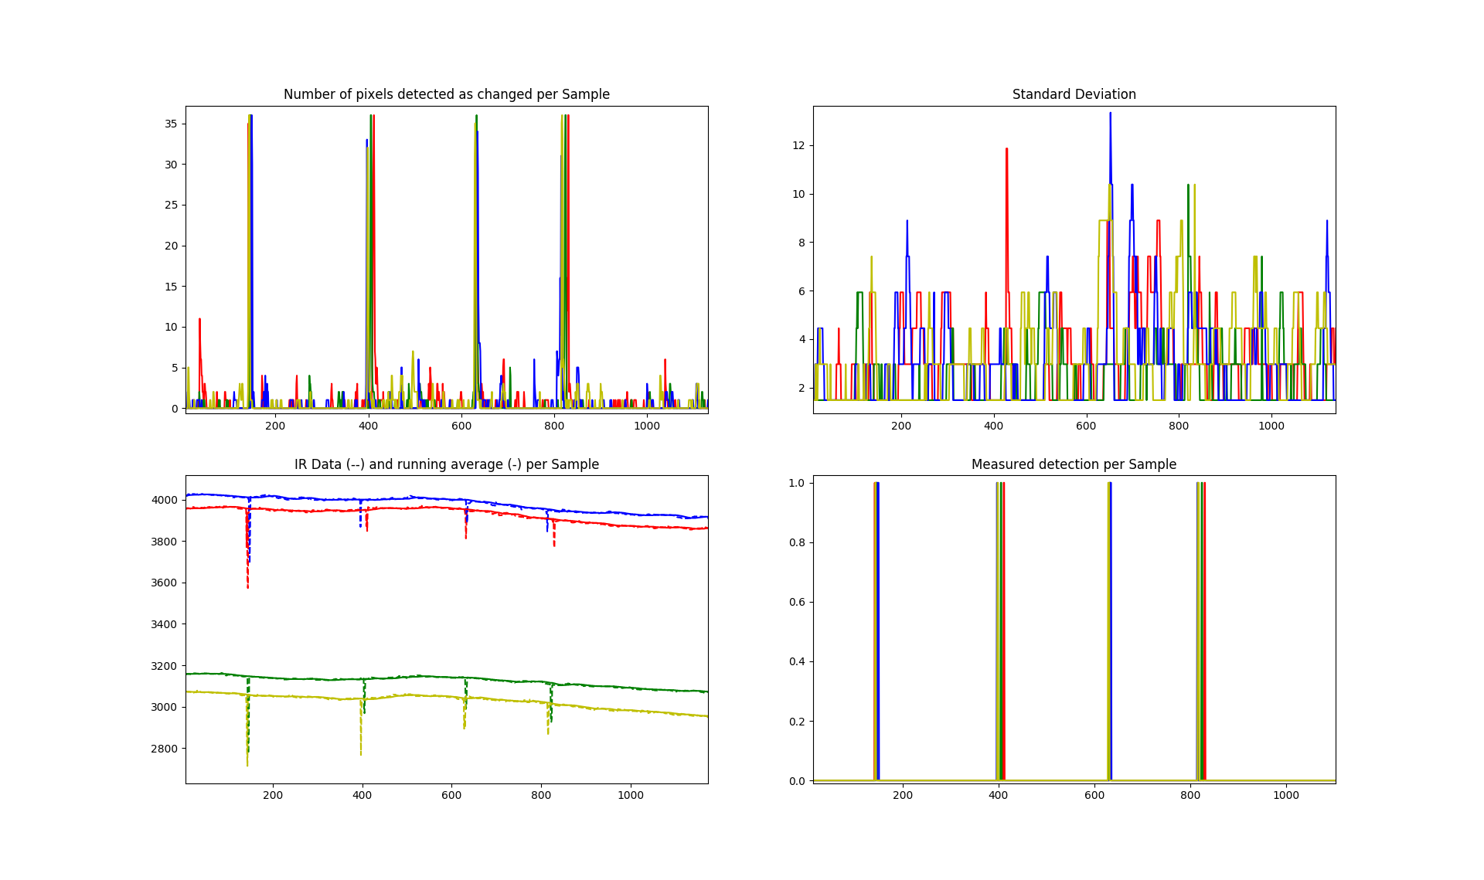

This test lasted approximately two minutes and fifteen seconds. The test subject walked back and forth twice (4 total intrusions) at distances varying between 4 feet and 25 feet. The algorithm continues to behave admirably with at most 12 pixels signaling a false alarm while detections are very clear spikes.

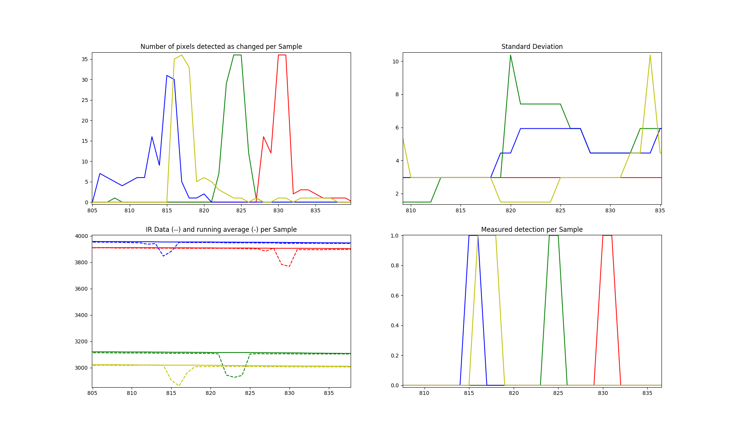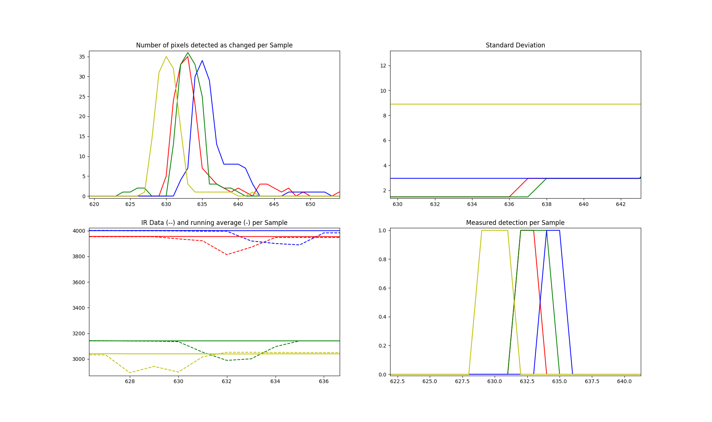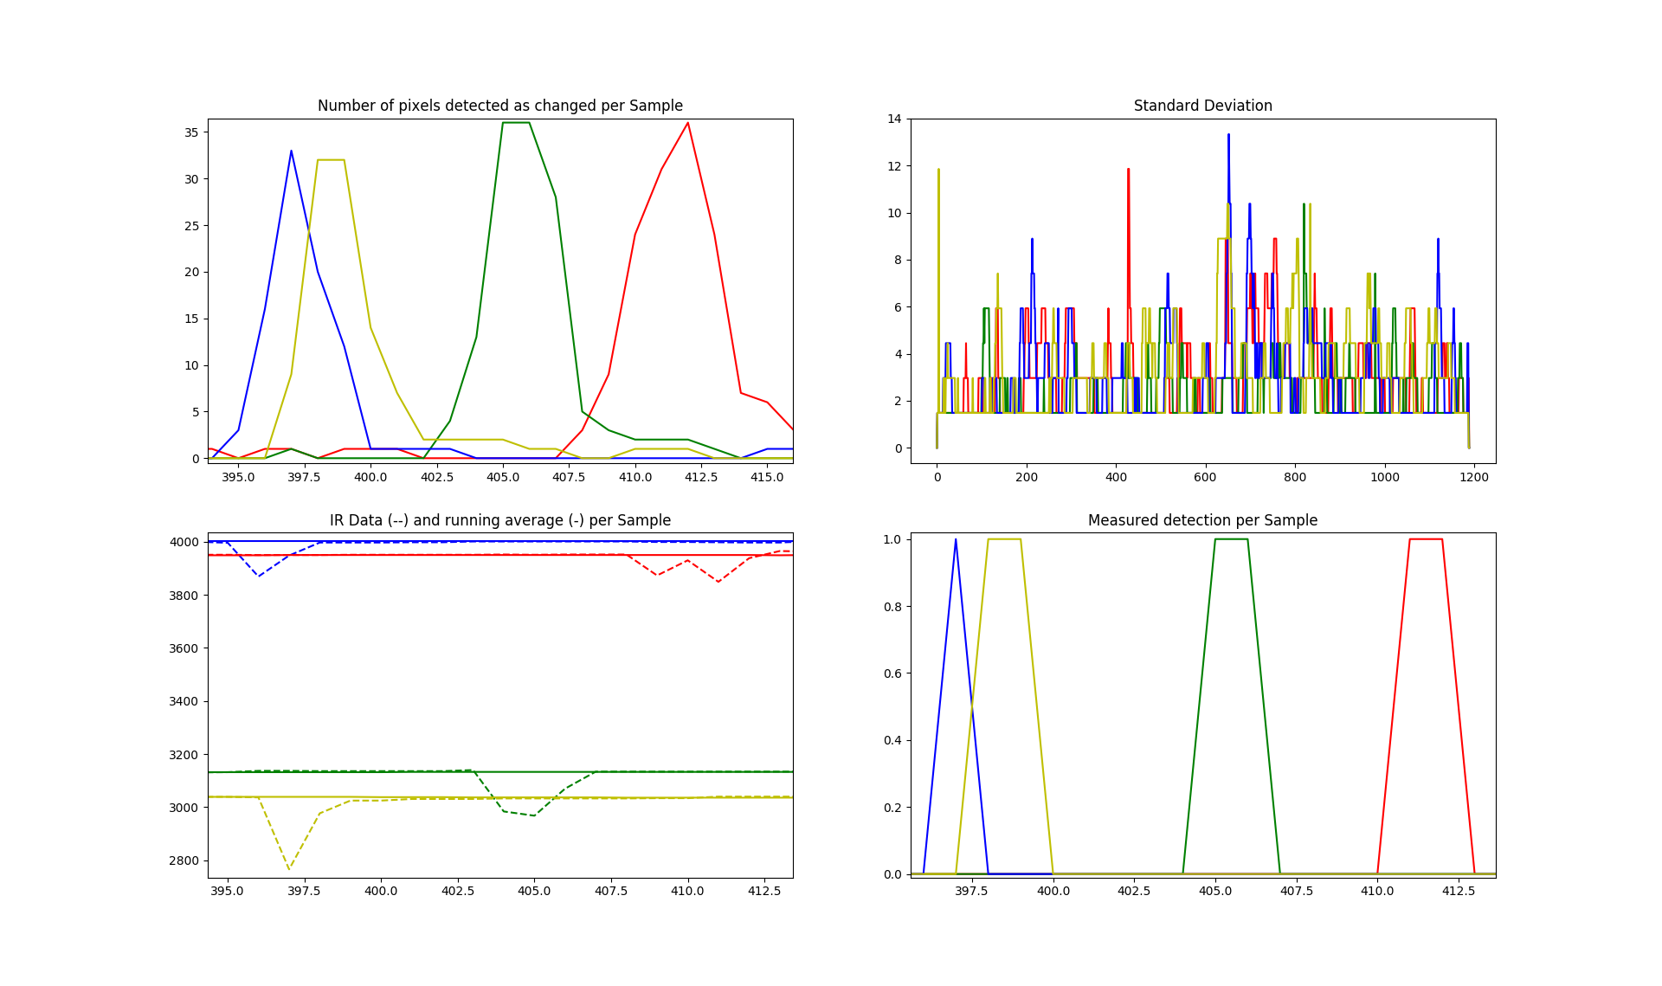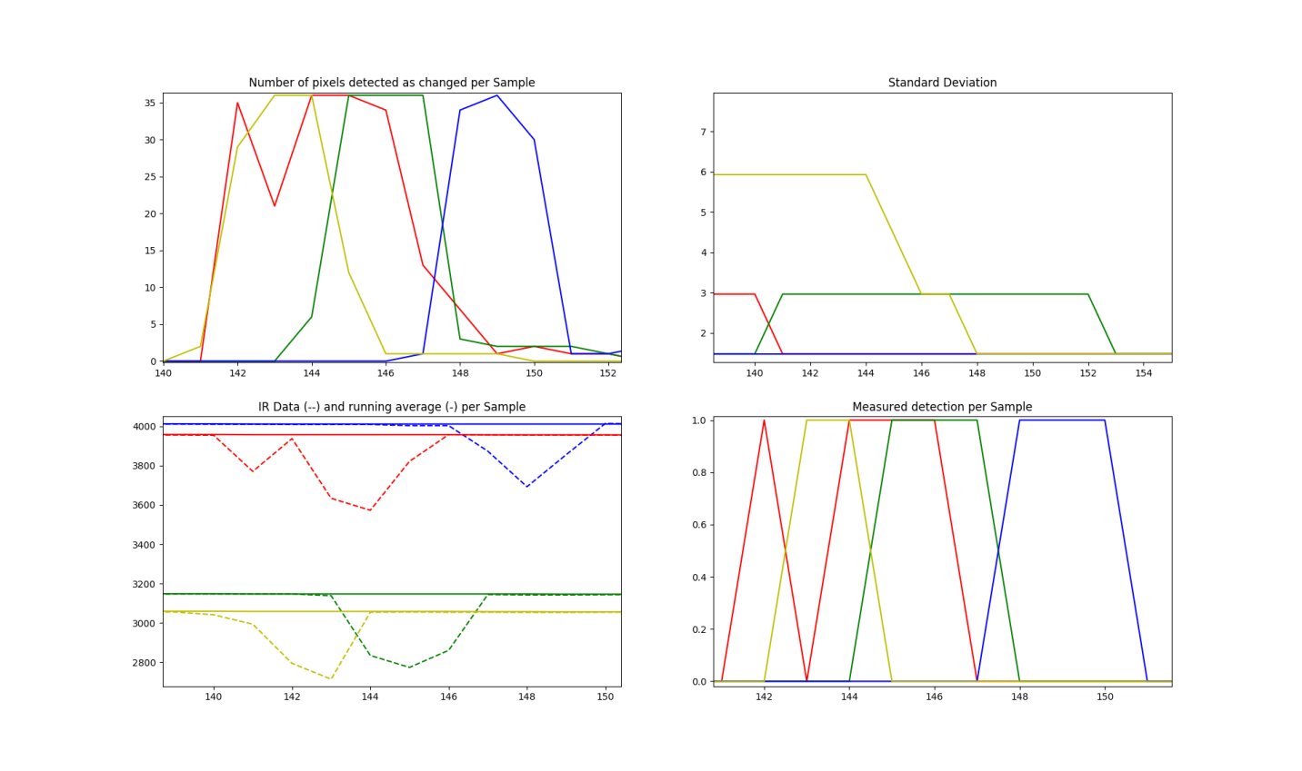

11:40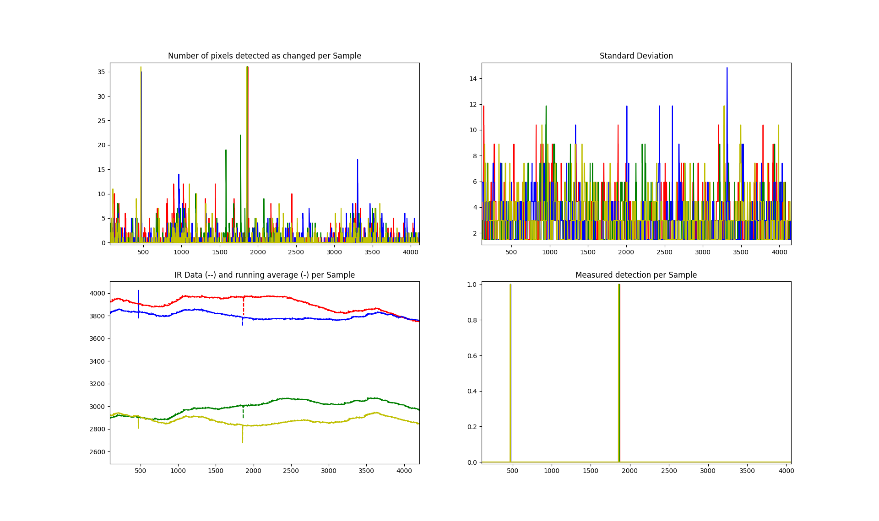

This test lasted 477 seconds (nearly 8 minutes) allowing the ambient temperature to wander. The largest range of this temperature is seen in the red graph and drifts between 3980 and 3736 in IR sensor value. Despite this drifting the algorithm performs very well, only identifying the two intrusions.

